An Bord Pleanála Oral Hearing

# In the matter of an application for a Railway Order pursuant to the Transport (Railway

Infrastructure) Act 2001 (as amended and substituted) ('the 2001 Act") Córas lompair Éireann / Iarnród Éireann

DART+ West Electrified Heavy Railway Order { ]

Agreement between:

Córas lompair Éireann (CIÉ) Iarnród Éireann/Irish Rail

-and-

First Party

Seán Malone as personal representative of the late John Malone and Gráinne Malone

Second Parties

SCHEDULED AGREEMENT

The following Scheduled Agreement has been reached between CIÉ/Iarnród Éireann-Irish Rail (“CIÉ/IE”) of the first part and Seán Malone as personal representative of the late John Malone and Gráinne Malone of the second part (“the parties") in relation to the aforesaid application for a Railway Order:

1. Seán Malone as personal representative of the late John Malone and Gráinne Malone withdraw the objection of the late John Malone and Gráinne Malone dated

25th October 2022 (05857S-22 An Bord Pleanála date stamp 27th October 2022) to

the application of CIÉ/IÉ for the DART+ West Electrified Heavy Railway Order [ ] (“the Railway Order") and support the granting of the Railway Order.

1. The parties agree that if An Bord Pleanála “the Board”) is of the view that it would be appropriate to grant the Railway Order pursuant to the provisions of section 43 of the Transport (Railway Infrastructure) Act 2001 (as amended and substituted) (“the 2001 Act”’), this Scheduled Agreement shall, subject to the decision of the Board under section 43(2) of the 2001 Act, be included as an Agreement t‹› the Thirteenth Schedule of the draft Railway Order (or such other or alternatively numbered Schedule as the Board may decide) and. where required, pan of the provisions of

this Agreement may be included as (a) condition(s) in the Eleventh Schedule of the draft Railway Order (or such other or alternatively numbered Schedule as the Board may decide).

1. This Scheduled Agreement is strictly without prejudice to the rights of Seán Malone as personal representative of the late John Malone and Gráinne Malone, their respective heirs and successors, to claim compensation arising from the compulsory acquisition of their interests in the property at Station House located at Ashtown, Dublin 15 (“the Property") including pursuant to the provisions of section 45 of the 2001 Act and the coming into operation of the DART+ West Electrified Heavy Railway Order [ ] pursuant to the 2001 Act and consequent upon the service of a Notice to Treat.
2. It is intended that the works authorised by the Railway Order ("the Works") will include inter alia the closure of the existing level crossing. Following the implementation of the Works, pedestrian and vehicular access from the public road to the Property shall be maintained. The works to facilitate such access are set out in the drawings appended to this Agreement at **Appendix 1.**
3. The Boundary wall between the railway and the Property shall be maintained and a discrete railing shall be constructed by CIÉ/IÉ on of the railway side of the wall over one third of the portion of the was! closest to the existing level crossing. The entrance gate will be replaced as part of the Works with one matching the design of the proposed railing. The raiding will be detailed so as to avoid impact on daylight at Station House. The details of the proposed boundary wall and the nailing are set out in the drawing appended to this Agreement at Appendix 1. CIE/I I- will liaise with Seán Malone and Grainne Malone on the final details of the proposed railing.

The proposed pedestrian cycle bridge at Ashtown Station will be designed with low level lighting incorporated into handrails rather than discrete lighting columns to mitigate light spill to Station house.



7. Overhead electrical line support structures in proximity to Station House will be of a cantilever type with posts and foundations located south of the railway. Individual posts will be located as remote from the house on the Property as is practicable. consistent with the overhead electrical system to be implemented as part of the Works.

1. Permanent vehicular access will be maintained to Station House. CIÉ/IÉ agree to implement the following measures to mitigate the risk of parked vehicles obstructing access to the Property:
   1. the urban landscaping fronting the Property will implement a pallet in respect of paving which will be designed to discourage parking;
   2. measures will be used to further discourage inappropriate parking;
   3. a dropped kerb detail will be provided on the southern edge of the proposed roundabout to clarify the non-vehicular character of the access. This will incorporate a dropped kerb;
   4. targeted signage will be implemented in the design prevent parking.

Indicative details of the proposed arrangement are set out in the drawing appended to this Agreement at **Appendix 1**. The details will be subject to further development as part of the detailed design, CU/IE will liaise with Sean Malone and Grainne Malone on the final design detail.

1. The contractors appointed by CU/IE (“the Contractors") shall implement a Dust Mitigation Plan ("the plan"). The plan will require the Contractors to undertake daily inspection, of the Malone property, to monitor dust, record inspection results, and make the log available to Sean Malone and Grainne Malone when asked. This

should include regular dust soiling checks of surfaces such as boundary walls, cars and window sills, with cleaning to be provided if necessary. It will provide for

increased frequency of site inspections by the person accountable for air quality and dust issues on site when activities with a high potential to produce dust are being carried out and during prolonged dry or windy conditions.

1. Gréinne Malone shall have the option of availing of reasonable appropriate alternative accommodation, to be provided at the expense of CIE/IE, for such time as the Works and/or any associated compounds are in operation within 100m of the property, including costs of furniture removals, transport costs, travel costs etc.
2. In the event that Grainne Malone decides to avail of alternative accommodation, then for any such period:
   1. CU/IE and the Contractors will have the right to lim it access t‹o the Property;
   2. Sean Malone and Grainne Malone will give 24 hours notice tc the Contractors should they wish to access the Property;
   3. the Contractors shall use their best endeavours to facilitate such access by Sean Malone and Grainne Malone; and

(iv) in emergency circumstances, the Contractors will be required to afford access

to the Property without the need for prior notice.

1. In the event that Grainne Malone decides not to avai! of alternative accommodation, then for any such period:
   1. CIE/IIE and the Contractors will be required to maintain acces!s to the Property at all times except for short periods (less than 1 week) where vehicular access may be restricted with prior notification, 4 weeks in advance of the associated Works; and
   2. where vehicular access is blocked, alternative secure parking will be made available by the Contractors at a Construction Compound within 200m of Station House.
2. The Contractors shall, before the commencement of any of the \/Vorks within 50 metres of the ProDerty, conduct a detailed structural survey and assessment of the Property and shall prepare a repon detailing the findings. A further condition survey will be carried out post construction. A copy of the reports will be grovided to Sean Malone as personal representaive of the late John Malone and Grainne Malone and to Julian Keenan, Director of Trafficwise Limited.
3. The Contractors shall monitor the condition of the Property during the Works. During any period when works are carried out within 50m of the property then the Propeny will be inspected on a weekly basis.
4. CU/IE agree to impose the following constraints on the Contractc›rs in respect of vibrations at the Property:
   1. the proposed construction works will be carried out in compliance with the recommendations in BS5228-Prt 2:2009 +A1 :2014: Code of practice for noise and vibration control on construction and open sites;
   2. the maximum peak particle velocities due to intermittent vibrations at the Property will be limited to 4mm/s for frequencies less than 1fJhz and 10mm/s for frequencies between 50 and 100hz;
   3. for continuous vibrations the equivalent limits will be 2. 0mrri/s and 5.0mm/s respectively; and
   4. the Contractor will be required to monitor vibrations before and during construction activity to ensure compliance with the requirements of the construction contract with CU/IE.

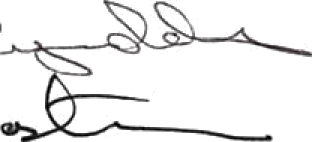

Céras lompair Eireann (CU) larnrod Eireann-Irish Rail

Date:  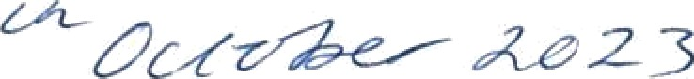 Witnessed by:

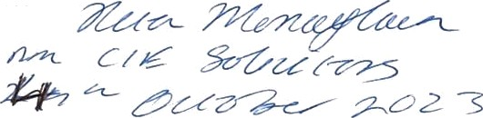

Date:

Signed:



Sean Malone as personal representative of the late John Malone



# Witnessed By:

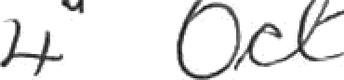

Signed:

# Gréinne Malone



Witnessed By:

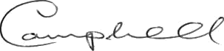

Appendix 1